Pray to Alert Nuclear War
February 12, 2018

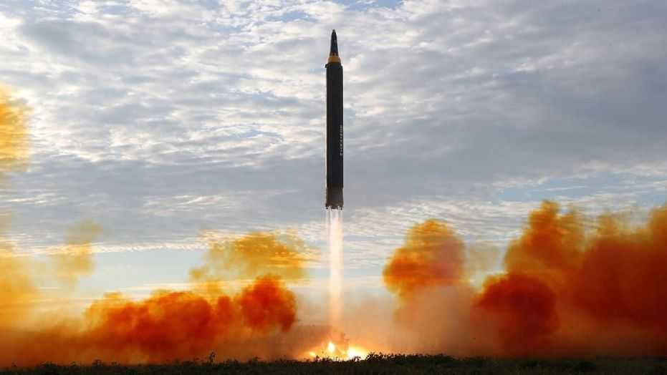
Precious Jesus, thank you so much for having things under control. Please help us to console You in these difficult times, when nuclear war is looming on the surface with North Korea. Please help us to console you and pray for all concerned, that this crisis might pass without souls being hurt. Amen.

Thank you, Lord – that YOU are in charge of our days, and You are so loving and merciful. Thank you for averting all of the things that are going on right now – the potentials with the Olympics and so on. And please, help us all to pray and intercede for the situation.

Well, my Heartdwellers. We have been having several visions, and we are in grave danger of nuclear war right now. Apparently, N.K has shot off at least three nuclear warheads that have been taken down, and radiation has been released into the air as a result of it. One over England and another one on the way to Hawaii was taken down. So, there is radiation/fallout that will be happening from this, at least as far as my understanding goes.

What I wanted to ask you to do is to please, start drinking Miso soup. And start praying. Because I think Kim (Jon Il) is using the Olympics as a cover to try and attack the United States without retaliation. So, it’s pretty serious right now. We need to be praying the Divine Mercy chaplet, day and night if possible.

It really IS serious.

But I’m holding on to the Lord’s promises to us, that He’s going to handle this. So, please pray for President Trump for tremendous wisdom, and his generals for tremendous wisdom in knowing exactly what to do. And what NOT to do.

But we have been interceding very heavily. Ezekiel, Carol and I and several of the prayer group members have been in very heavy intercession for the country.

So, this is going to be a short message because I’m not at home right now. But I wanted to let you know that this is a time of absolute, critical importance with prayer. Because these wicked people are using the Olympics like the Taliban and others use innocent families for cover, to be able to do their dirty work. And we really need to go with whatever the Lord allows for Korea.

God the Father is so grieved. Jesus, Holy Spirit are so grieved over the collateral damage of a nuclear war, or a nuclear strike. Or any kind of strike on North Korea. But it’s gotten to the point where they have been aggressors towards us. So, we just need to pray for tremendous wisdom, and supernatural intervention for all of this.

In the meantime, please keep us in prayer as well.

I love you all very much. Thank you for your prayers. And let’s keep praying and see this thing through to the right conclusion. Amen.

